Principio del formulario
The following line was displayed in the output of the show ip route command.
R 192.168.3.0/24 [120/3] via 192.168.2.2, 00:00:30, Serial0/0
What is the value of the routing metric?
 | 3
 | 12
 | 20
 | 30
 | 120

2 | Principio del formulario
  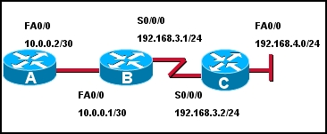
  Refer to the exhibit. All routers are running RIP. Which selection demonstrates the criteria of a boundary router?
  Router A
  Router B
  Router A and Router B
  Router C
  Router A and Router C

3 | Principio del formulario
  Which of the following is considered a limitation of RIP v1?
  RIP v1 does not send subnet mask information in its updates.
  RIP v1 is not widely supported by networking hardware vendors.
  RIP v1 consumes excessive bandwidth by multicasting routing updates using a Class D address.
  RIP v1 requires enhanced router processors and extra RAM to function effectively.
  RIP v1 does not support load balancing across equal-cost paths.
  RIP v1 authentication is complicated and time-consuming to configure.
4 | Principio del formulario
  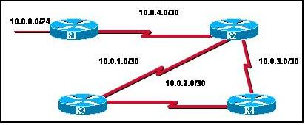
  Refer to the exhibit. The routers are all connected via serial point-to-point links. What three problems will RIPv1 have on this network that would be alleviated by RIPv2? (Choose three.)
   | unsecure updates
   | broadcast update traffic
   | configuration complexity
   | variable subnet masks
   | slow convergence
   | lack of event triggers

5 | Principio del formulario
  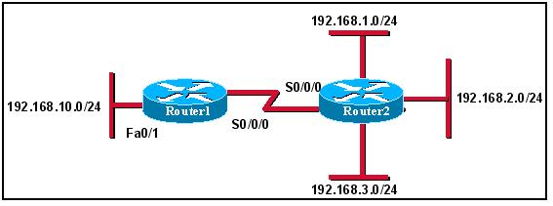
  Refer to the exhibit. The network shown is running RIPv1. The 192.168.10.0/24 network was recently added and will only contain end users. What command should the network administrator configure on Router1 to prevent RIPv1 updates from being sent to the end user devices on the new network while still allowing data packets to be forwarded?
  no router rip
  network 192.168.10.0
  no network 192.168.10.0
  passive-interface fastethernet 0/1
  passive-interface serial 0/0/0
6 | Principio del formulario
  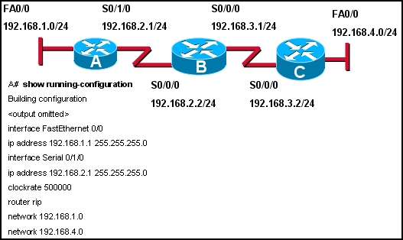
  Refer to the exhibit. Hosts on the 192.168.1.0 and 192.168.4.0 networks cannot communicate. What is the cause of this problem?
  improper address on serial 0/1/0
  improprer address on fastethernet 0/0
  incorrect network statements
  the fa0/0 must be configured as passive

7 | Principio del formulario
  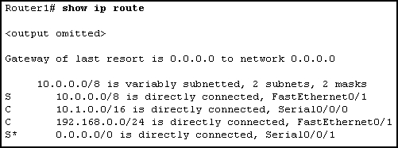
  Refer to the exhibit. Router1 is running RIPv1. What command was entered into Router1 to configure the gateway of last resort?
  no auto-summary
  ip default-network 0.0.0.0
  ip default-gateway 10.0.0.0
  ip route 0.0.0.0 0.0.0.0 S0/0/1
8 | Principio del formulario
  Which command or set of commands will stop the RIP routing process?
  RouterB(config)# router rip
  RouterB(config-router)# shutdown
  RouterB(config)# router rip
  RouterB(config-router)# network no 192.168.2.0
  RouterB(config)# no router rip
  RouterB(config)# router no rip

9 | Principio del formulario
  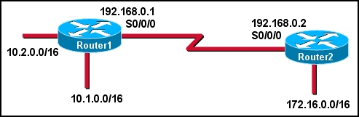
  Refer to the exhibit. The network is running RIPv2. What is required to make Router1 advertise a summary address of 10.0.0.0/8 to Router2.
  network 10.0.0.0 255.0.0.0
  default-information originate always
  ip summary-address rip 10.0.0.0 255.0.0.0
  nothing, RIPv2 will autosummarize 10.0.0.0 255.0.0.0
10 | Principio del formulario
  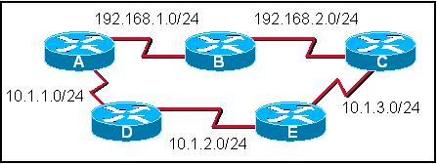
  Refer to the exhibit. If all 192.168.x.x/24 networks are advertised by RIPv1 and all 10.x.x.x/24 networks are running EIGRP, which path would a packet moving from router A to router C take, and why?
  A-B-C, because the administrative distance is lowest
  A-B-C, because the path is the most direct
  A-B-C, because RIP is the least complicated of the two routing protocols in use.
  A-D-E-C, because the administrative distance is lowest
  A-D-E-C, because the path is the most direct
  A-D-E-C, because the metric is best

11 | Principio del formulario
  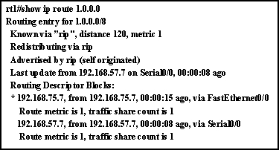
  Refer to the output from the show ip route command. What can be concluded from the output of this router command?
  A preferred route to the destination has not been set.
  There are two equal cost paths to network 1.0.0.0.
  Both interfaces are being used equally to route traffic.
  A variance must be set to load-balance across multiple paths.
12 | Principio del formulario
  Which command will display RIP activity as it occurs on a router?
  debug ip rip
  show ip route
  show ip interface
  show ip protocols
  debug ip rip config
  show ip rip database

13 | Principio del formulario
  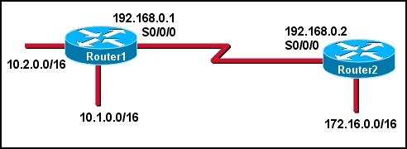
  Refer to the exhibit. Router1 and Router2 are running the RIPv1 protocol. The network administrator configures the command network 10.1.0.0 on Router1. What network will Router1 advertise to Router2?
  10.1.0.0/16
  10.1.0.0/8
  10.0.0.0/16
  10.0.0.0/8
14 | Principio del formulario
  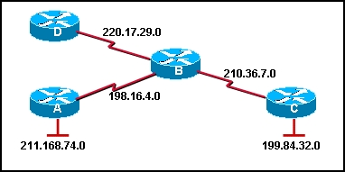
  Which of the following would be the correct command sequence to enable RIP on Router B for all connected networks?
  RouterB# router rip
  RouterB(router)# network 210.36.7.0
  RouterB(router)# network 220.17.29.0
  RouterB(router)# network 211.168.74.0
  RouterB(config)# router rip
  RouterB(config-router)# network 198.16.4.0
  RouterB(config-router)# network 211.168.74.0
  RouterB(config-router)# network 199.84.32.0
  RouterB(config)# configure router rip
  RouterB(config-router)# network 210.36.7.0
  RouterB(config-router)# network 199.84.32.0
  RouterB(config-router)# network 211.168.74.0
  RouterB(config)# router rip
  RouterB(config-router)# network 198.16.4.0
  RouterB(config-router)# network 210.36.7.0
  RouterB(config-router)# network 211.168.74.0
  RouterB(config)# router rip
  RouterB(config-router)# network 198.16.4.0
  RouterB(config-router)# network 210.36.7.0
  RouterB(config-router)# network 220.17.29.0

15 | Principio del formulario
  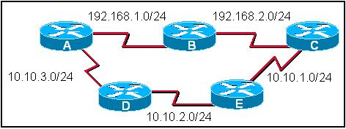
  Refer to the exhibit. All routers in the exhibit are running RIP v1. The network administrator issues the show ip route command on router A. What routes would appear in the routing table output if the network is converged? (Choose two).
  R 192.168.2.0/24 [120/1]
  C 192.168.2.0/24 [120/1]
  R 10.10.3.0/24 [120/0]
  C 10.10.3.0/24 [120/1]
  R 10.10.1.0/24 [120/2]
  R 10.10.1.0/24 [120/3]
16
Principio del formulario
Which two statements are true regarding the characteristics of RIPv1? (Choose two).
It is a distance vector routing protocol.
It allows variable length subnet masking.
The data portion of a RIP message is encapsulated into a TCP segment.
The data portion of a RIP message is encapsulated into a UDP segment.
It can use hop counts of no more than 16.
It broadcasts updates every 15 seconds.

